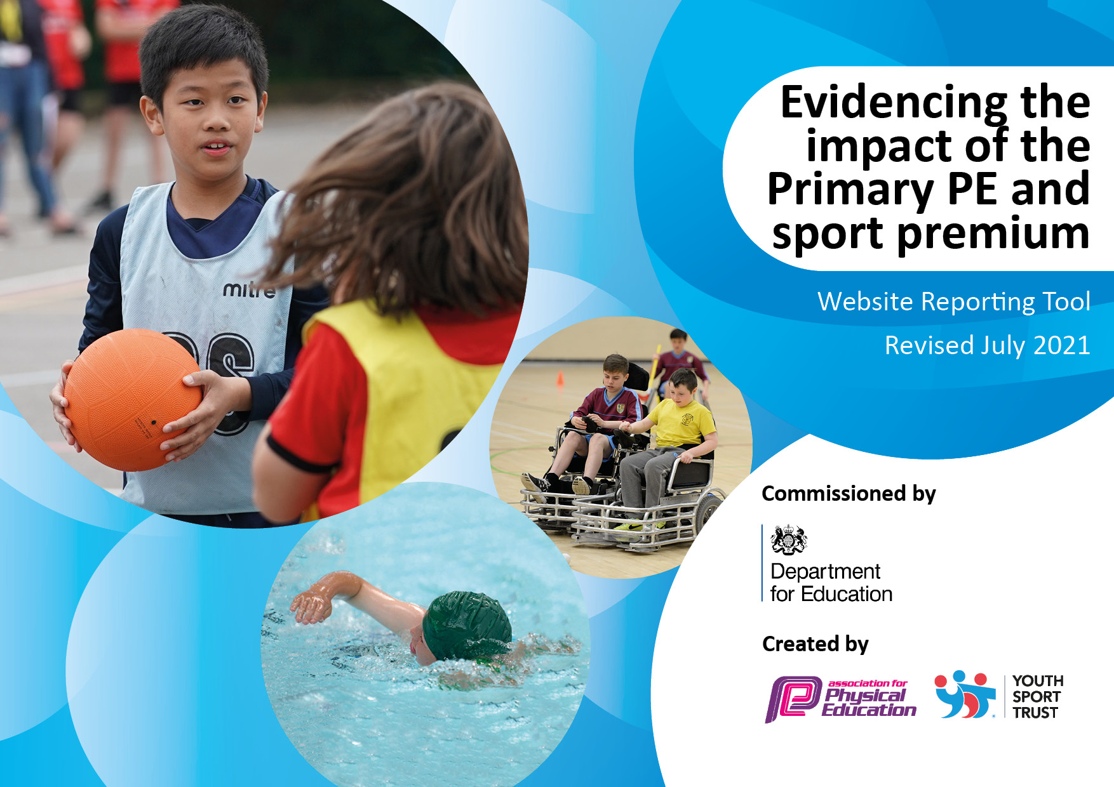
Sherrier CE Primary
July 2023
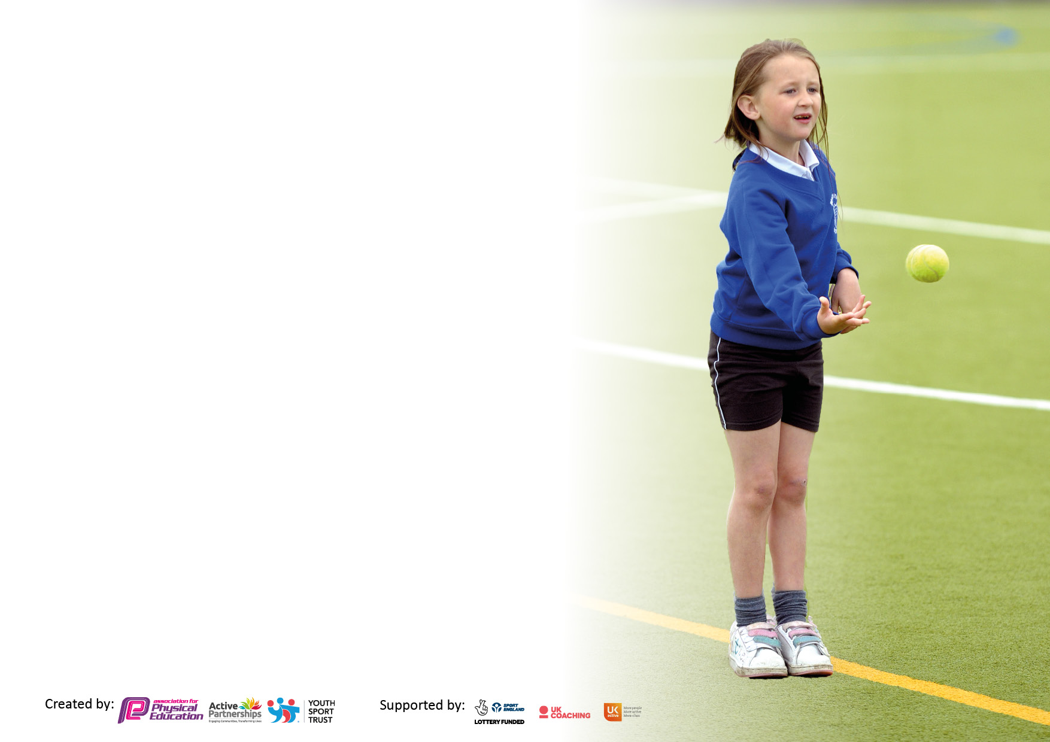

It is important that your grant is used effectively and based on school need. The Education Inspection Framework makes clear there will be a focus on ‘whether leaders and those responsible for governors all understand their respective roles and perform these in a way that enhances the effectiveness of the school’.

Under the Quality of Education Ofsted inspectors consider:
Intent - Curriculum design, coverage and appropriateness
Implementation - Curriculum delivery, Teaching (pedagogy) and Assessment
Impact - Attainment and progress

To assist schools with common transferable language this template has been developed to utilise the same three headings which should make your plans easily transferable between working documents.

Schools must use the funding to make additional and sustainable improvements to the quality of Physical Education, School Sport and Physical Activity (PESSPA) they offer. This means that you should use the Primary PE and sport premium to:

- Develop or add to the PESSPA activities that your school already offer
- Build capacity and capability within the school to ensure that improvements made now will benefit pupils joining the school in future years
- The Primary PE and sport premium should not be used to fund capital spend projects; the school’s budget should fund these.

Pleasevisitgov.ukfortherevisedDfEguidanceincludingthe5keyindicatorsacrosswhichschoolsshoulddemonstrate animprovement.Thisdocumentwillhelpyoutoreviewyourprovisionandtoreportyourspend.DfEencouragesschools to use this template as an effective way of meeting the reporting requirements of the Primary PE and sport premium.

We recommend you start by reflecting on the impact of current provision and reviewing the previous spend.

Schools are required to publish details of how they spend this funding, including any under-spend from 2019/2020, as well as on the impact it has on pupils’ PE and sport participation and attainment. All funding must be spent by 31st July 2022.

We recommend regularly updating the table and publishing it on your website throughout the year. This evidences your ongoing self-evaluation of how you are using the funding to secure maximum, sustainable impact. Final copy must be posted on your website by the end of the academic year and no later than the 31st July 2021. To see an example of how to complete the table please click HERE.

Details with regard to funding
Please complete the table below.

Total amount carried over from 2021/2022 | £ 0
Total amount allocated for 20022/2023 | £ 19 420
How much (if any) do you intend to carry over from this total fund into 2022/2023? | £ 0
Total amount allocated for 2022-2023 | £ 19 420
Total amount of funding for 2022/2023. To be spent and reported on by 31st July 2023. | £ 19.420
Swimming Data
Please report on your Swimming Data below.

Meeting national curriculum requirements for swimming and water safety.  N.B. Complete this section to your best ability. For example you might have practised safe self-rescue techniques on dry land which you can then transfer to the pool when school swimming restarts.  Due to exceptional circumstances priority should be given to ensuring that pupils can perform safe self rescue even if they do not fully meet the first two requirements of the NC programme of study | Children from Y4 are taken to local swimming pool in 6-8 weeks blocks, grouped into ability and led by qualified swimming instructors. We aim that children will learn to swim at least 25m safely using different strokes and survival techniques.
What percentage of your current Year 6 cohort swim competently, confidently and proficiently over a distance of at least 25 metres?  N.B. Even though your pupils may swim in another year please report on their attainment on leaving primary school at the end of the summer term 2020.  Please see note above | 98% Any non swimmers are taken again in the Summer term to local pool for intense swimming lessons in smaller groups led by a qualified instructor.
What percentage of your current Year 6 cohort use a range of strokes effectively [for example, front crawl, backstroke and breaststroke]?  Please see note above | 98%
What percentage of your current Year 6 cohort perform safe self-rescue in different water-based situations? | 80%
Schools can choose to use the Primary PE and sport premium to provide additional provision for swimming but this must be for activity over and above the national curriculum requirements. Have you used it in this way? | Yes to aid non swimmers in Year 4, 5 and 6 with additional lessons to learn to swim up to at least 25m for at least 5-6 weeks .

Action Plan and Budget Tracking
Capture your intended annual spend against the 5 key indicators. Clarify the success criteria and evidence of impact that you intend to measure to evaluate for pupils today and for the future.

Academic Year: 2022/2023 | Total fund allocated: £19 420 | Date Updated: July 2023
Key indicator 1: The engagement of all pupils in regular physical activity – Chief Medical Officers guidelines recommend that primary school pupils undertake at least 30 minutes of physical activity a day in school |  |  |  | Percentage of total allocation:
 |  |  |  | 35% £6236.00
Intent | Implementation |  | Impact
Your school focus should be clear what you want the pupils to know and be able to do and about  what they need to learn and to  consolidate through practice: | Make sure your actions to achieve are linked to your intentions: | Funding allocated: | Evidence of impact: what do pupils now know and what can they now do? What has changed?: | Sustainability and suggested next steps:
Providing targeted activities or support to involve and encourage the least active.  Inspire ALL students to get involved in 30 minutes of physical activity during school time and take part in physical activity outside of school. | The school delivered the Girls Active Lifestyles project, 6 weeks of activity for less active girls in year 5/6. The activity was chosen by the participants. This included (insert example). The participants also took part in a GALs celebration event at the local leisure centre. The girls took part in a range of activities including dance, yoga and cheer leading. The aim of the event was to signpost the participants to local community exit routes.  The school delivered the Live Active Do-Sometime project, 6 weeks of activity for less active boys in year 5/6. The activity was chosen by the participants. This included Archery . The participants also took part in a Aspiration Active event celebration at the local leisure centre. The children took part in a range of activities including wheelchair basketball, quidditch, and karate. The aim of the event was to signpost the participants to local community exit routes.  The school took part in the SLSSP Big Moves project designed for KS1 pupils who lack fundamental movement skills/physical literacy.  The school participated in the Energise Club. The 10 weeks of sessions delivered by SLSSP staff with inactive/less confident Year 3 and 4 for Energise pupils. The sessions included fun physical games and mindfulness.  The school took part in an Inclusive Sport Club targeting SEND pupils. A coach from SLSSP delivered a 6 week club alongside a member of staff.  The whole school took part in the Move It March project. Each child was given a physical activity tracker to fill out during March 2023. Certificates and prizes were awarded to children who achieve physical activity milestones (250 active minutes=Bronze, 500 active minutes=Silver, 750 active minutes=Gold and 1000 active minutes=Platinum). Pupils were also given points for achieving milestones and the most active class won a trophy.  We promoted SLSSP holiday resources to all parents and students. SLSSP produced resources to inspire children to be active and healthy over the Christmas, Easter and Summer holidays. | £2650 (South Leicestershire SSP Membership)  SLSSP Membership (see above)  SLSSP Membership  SLSSP Membership  SLSSP Membership  SLSSP Membership  SLSSP Membership  Football and fitness Sports Coaches  SLSSP and other fitness and childcare providers | All 10 girls enjoyed the sessions and confidence improved from the beginning of the sessions to the end after the 6 week sessions of yoga, dance and cheerleading.  Girls had a questionnaire at the beginning of the Primary GALS event about their attitudes to physical activity and then redid this. Progress is enjoyment in PA had increased and more girls wanted to be a part of a PA outside of school.  (94% of girls enjoyed their physical activity/ 86% of the girls wanted to continue to do the sport outside of school)  Children’s enjoyment levels increased and perception on exercise increased in %. After the 6 weeks, 96% of the children realised exercise could be enjoyable.  See Big Moves Report 2023  96% of the 15 children participating made an improvement of movements by the 6 weeks compared to 24% of children at week 1.  15 children took part in Energise Club from Year 5 (Year 4 could not do this due to Swimming Lessons) Children continued to use the mindfulness techniques and activities in lessons.  Inclusive games – 15 SEND children from year 5 and 6 took part. Increased participation and enjoyment. Some children wanted to attend the Primary GALS event at Harborough Leisure Centre.  Most active class was 5AB.  A total of 278 (66%) children were active in March 2023. (See Move it March Monitoring Report 2023)  All adverts placed on the parents side of class dojo. Newsletters promoting competitions and wellbeing were sent out in monthly bulletins.  A 82% uptake in participation in the after school clubs- multi sports, gymnastics, basketball, tri golf and tennis. Children from different groups including SEND, PP and EAL took up the offer.  Enrichment Activities after school for children to inspire using a range of supporting activities. | Develop further extra curricular girls activities and target those girls who may be non-participants outside of school and disadvantaged children. Using external coaches for this.  Develop girls football team in light of the Women’s Football Euros this summer 2022.  Offer opportunities to try new sports/physical activity by having a range of enrichment sporting opportunities across the year.  Big Moves to continue in Y1 and begin in Autumn term 2023 for EYFS. School already has trained leads.  Both Energise and Inclusive games sessions will continue in 2023-2024.  Inclusive games to continue in 2023-2024.  School has signed up for Active travel Month in October 2023 and will be taking part in Move it March 2024.  Other enrichment opportunities will be available in Autumn Term 2023- Art, Robotics, Drama and Choir. PE Lead to monitor uptake and vulnerable group participation.
Key indicator 2: The profile of PESSPA being raised across the school as a tool for whole school improvement |  |  |  | Percentage of total allocation:
 |  |  |  | £9074.00
Intent | Implementation |  | Impact
Your school focus should be clear what you want the pupils to know and be able to do and about  what they need to learn and to  consolidate through practice: | Make sure your actions to achieve are linked to your intentions: | Funding allocated: | Evidence of impact: what do pupils now know and what can they now do? What has changed?: | Sustainability and suggested next steps:
To engage student voice and use students’ leaders to raise the profile of PE and School Sport.  Encourage active travel to school.  Embedding Physical Activity and Well-being into the school day  Encourage and foster a love of the learning outdoors.  Ensure correct PE equipment is used in PE lessons. | The school trained 4 students to become Sports Ambassadors to promote physical activity. The ambassadors formed a school sport organising crew and devised action plan to promote PE and physical activity in school.  The ambassadors took control of a PE and school sport noticeboard. The notice board included the physical activity guidelines infographics. Younger students were encouraged to submit pictures of themselves taking part in physical activity, sporting achievements were included on the noticeboard.  Sporting achievements were also celebrated sport in assemblies. The school newsletter to contain information about physical activity, sports clubs and fixtures.  4 students were trained to become Well-being Ambassadors to support mental health and internet safety in school. The Well-being Ambassadors have been supporting the Sports Ambassadors.  Took part in an Active Travel Month. During October 2022, students and families are encourage to walk to school. A wallchart was given to each class to record children actively travelling to school. A trophy was given to the class that actively travelled the most.  Playground leaders and lunch time supervisors trained to make lunch times more active using the ‘Happy Lunchtime’ approach to rewarding positive behaviour in line with the school’s berhaviour policy.  We utilised the SLSSP Well-being resources to support pupils.  These included:  5 minute videos played during form time (registration). The focus was on mental health, dealing with anxiety, anger and bereavement and relaxation techniques.  5 minute brain and active breaks. The brain and active breaks allowed mental refocus and the opportunity to expel some energy. There was a cross-curricular theme.  Regular Forest School sessions led by a Level 3 trained lead. Each class has a 2 hour session 1x a fortnight in the PPA sessions. This is to encourage children to be outside and increased PESSPA and wellbeing.  Purchase new PE equipment for lessons, particularly the correct sizer netballs, basket balls and footballs. | SLSSP Membership  SLSSP Membership  SLSSP Membership  SLSSP Membership  SLSSP Membership  SLSSP Membership  Equipment  £2500.00  SLSSP Membership  Staffing costs at £5074 for Forest School Lead  Davies Sports  £1500.00 | Sports Ambassadors lead on many physical activity in school- sports day organising and leading events, leading PE lessons, leading Happy Lunchtime activities.  Sports Ambassadors lead assemblies and always attend school competitions.  PE notice board in Small hall updated with competition news.  Ambassador training- October 2022  Certificates given in Celebration Assemblies weekly.  Online Newsletters given out to parents about limited time on devices at home (Autumn 2022)  See Active Travel month report October 2022.  Purchased new equipment and trained relevant staff to lead Happy Lunch time sessions. To be introduced in Autumn term 2022.  Support for our parents in wellbeing- signposting to agencies and help through monthly newsletters.  Wellbeing activities and sessions during school holidays have been popular.  Active lesson breaks using online videos are popular for the teachers to use when children need an active break.  Use of Imoves videos in lessons  Teachers assess outdoor learning at whether the children meet expectations. Forest School approach is now linked to the schools curriculum and Mantle of the Expert enquiries.  Children enjoy being outside and can use skills in challenges set independently and with others more.  See Outdoor Learning Assessments  Replenishing PE equipment | The school continues to train and give opportunities to the Sports Ambassadors. Sports  Ambassadors will be trained next year to ensure student voice in represented in the school’s physical activity offer.  The school continues to promote active travel through school newsletters and social media. The school with closely with the Leicestershire County Council Officer to promote Active Travel including encouraging parents to park and stride.  The lunch time supervisors are trained to put on a range of activities/games during lunch. The lunchtime supervisors have created zones to ensure a variety of activities can take place during lunch. The Playground Leaders will continue to support the other children particularly those in  KS1.  Mental health Day November 2023 and Child Mental Health Weeks will be promoted in school 2024.  Forest Schools Sessions will continue in 2023-2024.

Key indicator 3: Increased confidence, knowledge and skills of all staff in teaching PE and sport |  |  |  | Percentage of total allocation:
 |  |  |  | 0%
Intent | Implementation |  | Impact
Your school focus should be clear | Make sure your actions to | Funding | Evidence of impact: what do | Sustainability and suggested
what you want the pupils to know | achieve are linked to your | allocated: | pupils now know and what | next steps:
and be able to do and about | intentions: |  | can they now do? What has
what they need to learn and to |  |  | changed?:
consolidate through practice:
Promote a whole school approach to PE and School Sport -providing all staff with professional development, mentoring, appropriate training and resources to help them teach PE and sport more effectively to all pupils, and embed physical activity across your school.  To develop a balance bike lead for sessions in EYFS. | Our PE co-ordinator has taken part in local PE Subject Leader meetings. The PE Co-ordinator shared the learnings with all colleagues during staff meetings  The PE co-ordinator took part in the Leicestershire and Rutland PE Conference, taking part in a variety of workshops including a assessment in PE workshop. The PE Co-ordinator shared the learning points with all staff.  To increase road safety in children and actively encourage physical participation and balance techniques in EYFS children. | SLSSP Membership  SLSSP Membership  Free training as part of the SLSSP. | Regular Staff Meetings (1 x per term) for PE lead to share the information to staff.  Staff meeting about PE assessments had with staff- PE assessments to be reviewed and shared with staff- Autumn term 2022.  EYFS children have had 8 balance bikes in the Summer term 2022 and regular balance bike sessions led by the trained member of staff.  86% increase in better posture and riding the bike with good balance and not wobbling. | SLT will continue to champion the PE co-ordinator role. The PE co-ordinator will deliver whole school staff workshops. The PE Co-ordinator will also survey staff to highlight areas of PE where further CPD is needed.  School to invest in new balance bikes using Sport Premium funding and as part of our intent to ensure children have good road safety knowledge.
Key indicator 4: Broader experience of a range of sports and activities offered to all pupils |  |  |  | Percentage of total allocation:
 |  |  |  | £4074.00
Intent | Implementation |  | Impact
Your school focus should be clear | Make sure your actions to | Funding | Evidence of impact: what do | Sustainability and suggested
what you want the pupils to know | achieve are linked to your | allocated: | pupils now know and what | next steps:
and be able to do and about | intentions: |  | can they now do? What has
what they need to learn and to |  |  | changed?:
consolidate through practice:
Additional achievements:  Provide all pupils with a broad and balanced PE curriculum and school sport offer, which includes alternatives to traditional sport.  Forest School Sessions as a regular timetabled slot in our curriculum offered to all children in FS to Y6. | A range of activities was offered to targeted groups through SLSSP membership (as outlined in Key Indicator 1).  Our KS1 pupils took part in a multi-skills and gymnastics festival designed to develop physical literacy and a range fundamental movement skills.  The school sent out the SLSSP Festive Challenge to all parents it promoted the SLSSP parent portal which contains information about local walking routes and fun physical activity videos.  Our school took part in the FA’s Girls Football week. This included virtual football challenges for girls and a design a football competition. The ideas of the week was to raise the profile girls football and increase participation.  Our school took part in lots sports challenges to raise awareness of the Commonwealth Games. The challenges were a part of the SLSSP’s Commonwealth Games virtual competition.  Our pupils take part in regular Forest School Sessions as part of our Ofsted action to improve outdoor learning and to increase physical activity- including orienteering, life skills, survival skills and teamwork. | SLSSP Membership  Staffing Costs  £4074 | Sherrier children enjoyed the competitions and opportunites to participate in sporting events.  KS1 and Year ¾ gymnastic team won Spirit of the Games award certifitcates, showing great sportsmanship and team work.  Parental feedback suggested they enjoyed the Festive Fun booklet and events to engage their child in physical activities over the Christmas period.  Y2, Y3, Y4 and Y5 took part in the Womens football competition to design a new football. One team reached the final. We had over 56 girls take part.  SEND children took part in the SEND Commonwealth games festival Autumn Term 2022.  Teachers assess outdoor learning at whether the children meet expectations. Forest School approach is now linked to the schools curriculum and Mantle of the Expert enquiries.  Children enjoy being outside and can use skills in challenges set independently and with others more.  See Outdoor Learning Assssments | Continue to provide enrichment activities led by qualified coaches after school.  Enter competitions as part of the SLSSP virtually and face to face in 2023-2024.  Premier League Stars have offered Sherrier free girls football kits for 2024.

Key indicator 5: Increased participation in competitive sport |  |  |  | Percentage of total allocation:
 |  |  |  | %
Intent | Implementation |  | Impact
Your school focus should be clear | Make sure your actions to | Funding | Evidence of impact: what do | Sustainability and suggested
what you want the pupils to know | achieve are linked to your | allocated: | pupils now know and what | next steps:
and be able to do and about | intentions: |  | can they now do? What has
what they need to learn and to |  |  | changed?:
consolidate through practice:
Increasing and actively encouraging pupils’ participation in the school competition. Ensuring competition is for all and not just ‘sporty’ children. | Subscription to SL SSP provides opportunities for high ability, lower ability, SEND and less active pupils.  Pupils took part in the following virtual competitions:  - WOMENS FOOTBALL  - 5K CHALLENGE  - MOVE IT MARCH  Pupils took part in virtual competitions. The personal/team challenges were designed to give all pupils the opportunities to take part in competition. | SLSSP Membership  SLSSP Membership  SLSSP Membership | Over 300 children participated in the virtual challenges and we saw an increased uptake of 45% more KS1 children taking part in the different challenges. | The school will continue to take part in competitions next academic year. SLSSP will promote a blended approach next year, both virtual and face to face competitions will take place. The school is committed to taking part in the local competitions.

Signed off by
Head Teacher: | LYNDSEY BECKETT
Date: | 31/07/23
Subject Leader: | KELLIE KIRBY
Date: | 31/07/2023
Governor:
Date:

