How are the changes in our world affecting animals and what can we do to protect them?  YEAR 2 SUMMER TERM  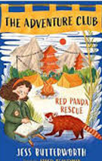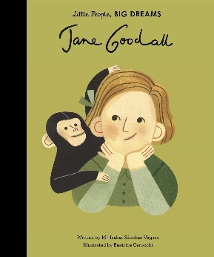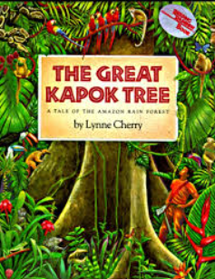 |  |  | English | Maths
 |  |  | Sentence Level and Grammar: recapping and embedding Y2 grammar, punctuation and spelling  Setting Descriptions  Descriptions of the Amazon Rainforest.  Recount  Trip to Woburn Safari Park.  I loved your book, here’s mine.  Creating own story book inspired by a favourite. | - Mass, Capacity and Temperature  - Fractions  - Time  - Problem Solving and Efficient Methods.  - Position and Direction  - Statistics
Science |  |  | Reading | Mantle of the Expert
Animals, including Humans (2)  - Animal reproduction  - Know that animals including humans have offspring which grow into adults.  - Know the basic stages in a life cycle for animals (inc humans)  Plants  - Know and explain how seeds and bulbs grow into plants.  - Know what plants need in order to grow and stay healthy (water, light, suitable temperature)  Investigations:  What is the life cycle of a ladybird?  Whose poo?  How does grass grow? |  |  | The Adventure Club Red Panda Rescue  Jane Goodall Little People Big Dreams  The Great Kapok Tree | How are changes in our world affecting animals and what can we do to protect them?  Link to Adventure Club book  Commission the team to rescue animals and provide temporary shelter.  Reports back to client.
 |  |  | Geography | Art and Design
 |  |  | - Identifying the continents and the animals that come from them.  Asia - Red panda – Nepal / Orangutan – Malasia  - Understanding the concept of endangered animals and the possibility of extinction (building from Yr1).  - Human activity and the impact on native wildlife – from deforestation to poaching, experimentation and entertainment.  - Rainforest biomes and where they appear in the world.  - Data handling in measuring primate population, keys and Venn diagrams. | Exploring the World Through Mono Print  Using a simple mono print technique to develop drawing skills, encourage experimentation and ownership.  OUTCOME: Mono printing ‘Change, Grow, Live’.  ARTIST: Xgaoc’o Xare
Music |  |  | Design Technology | PHSE /Jigsaw
Music Technology, Form and Structure  - Listen to, and make observations about, a variety of live and recorded music  - Experiment changing and combining sounds through technology  - Create and perform simple rhythms following a given structure  - Comment on own and other people’s performances using Yr 2 vocabulary learnt  20th Century Music  - Identify and perform features of Film music.  - Identify and perform features of The Beatles’ music.  - Identify and perform features of Modern Bhangra music.  - Create and practise a piece of music using features of different genres.  - Comment on own and other people’s performances using Yr 2 vocabulary. |  |  | - Select from and use a wide range of materials and components, including construction materials, textiles and ingredients, according to their characteristics.  - Build structures, exploring how they can be made stronger, stiffer and more stable.  - Generate, develop, model and communicate their ideas through talking, drawing, templates, mock-ups and, where appropriate, information and communication technology.  - Evaluate designs. | Relationships  - Know that everyone’s family is different.  - Know that families function well when there is trust, respect, care, love and co-operation.  - Know that there are lots of forms of physical contact within a family.  - Know how to stay stop if someone is hurting them.  - Know some reasons why friends have conflicts.  - Know that friendships have ups and downs and sometimes change with time.  Changing Me  - Recognise cycles of life  - Understand the natural process of growing from young to old.  - Recognising changes in body from being a baby to now.  - Recognise physical difference between boys and girls.
Computing | PE | RE
Data and information – pictograms  Creating Media – Digital Music  Programming B – Programming Quizzes | Unit 5 Applying Physical  Coordination Sending and Receiving  Agility: Reaction/Response  Unit 5 Applying Physical  Agility: Ball Chasing  Static Balance: Floor Work | What is the good news Jesus brings?  - Learn about the concept of ‘Gospel’ and the good news of forgiveness, peace and love that Christians believe Jesus brings.  - Learn about the instructions that Jesus gives in the Bible and how Christians follow his example and these instructions in order to behave in a Christ like way.  - Take time to consider whether Jesus’ good news is only good news for Christians or whether there are things for people from different worldviews to consider.  What makes some places sacred?  - Find out about various places of worship and why they are important to many believers.  - Look at key features of churches, mosques and synagogues learning about how these can vary within different traditions.  - Consider the similarities of places of worship and how they support their local communities in practical ways.

