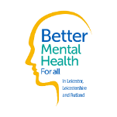

Neighbourhood Mental Health Cafés

Enderby Neighbourhood Mental Health Café
Every Tuesday
4.30pm – 8.30pm

Enderby leisure centre

Mill Lane
Leicester
LE19 4LX
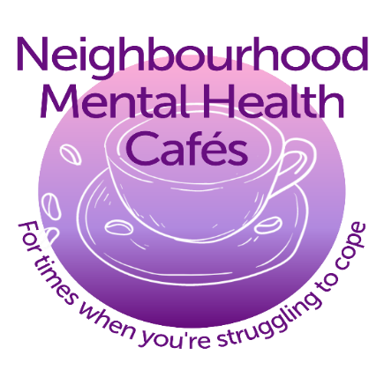

Neighbourhood Mental Health Cafés offer local support for people who need immediate help with their mental health. The cafés are drop-in centres for anyone to come and talk about their mental health - no appointment needed.

