How can people change the world?  YEAR 2 SPRING TERM  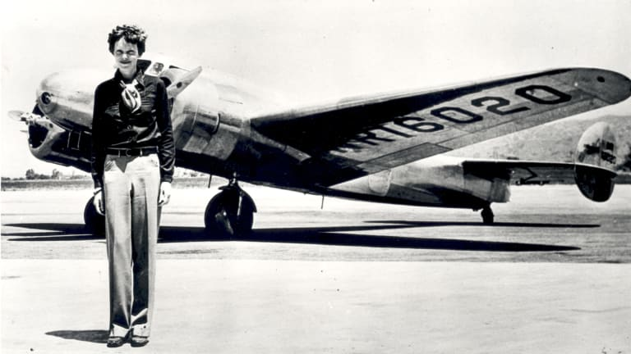 |  |  | English |  | Geography
 |  |  | Information texts  - Using subheadings  - Using commas in a list  - Sentence structure  Memoirs  - Using adjectives to describe feelings.  - Using speech |  | Place knowledge  Know the main differences between a place in England and that of a small place in a non-European country  Locational knowledge  Know the names of and locate the seven continents of the world  Know the names of and locate the five oceans of the world  Disciplinary Knowledge  Know the differences between human and physical geography
Science |  |  | Reading |  | History
Everyday materials  Identify different materials  Name everyday materials  • Know why a material might or might not be used for a specific job  Properties of materials  • Know how materials can be changed by squashing, bending, twisting and stretching  • Compare the use of different materials  • Compare movement on different surfaces  Animals inc. Humans  -Notice that animals, including humans, have offspring which grow into adults  -Find out about and describe the basic needs of animals, including humans, for survival (water, food and air)  -Know the name of body parts of the human body that can be seen  -Describe the importance for humans of exercise, eating the right amounts of different types of food, and hygiene.  Our Investigations are called -  What does friction do?  How does it feel?  We will learn how to  Ask simple questions  Perform simple tests  Gather and record data to help answer questions  Observe closely |  |  | Emma Jane’s Aeroplane - Katie Haworth and Daniel Rieley  Taking Flight: How the Wright Brothers conquered the skies - Adam Hancher  Flying Free: How Bessie Coleman’s dreams took flight - Karyn Parsons and R. Gregory Christie  Harley Hitch Takes Flight – Vashti Hardy  Focus on all of the VIPERS skills – vocabulary, infer, predict, explain, retrieve and sequence. |  | Chronological Knowledge  Order dates from the earliest to latest date on simple timelines  Describe memories and changes that have happened in their own lives  Discuss changes that have happened over time  Historical Enquiry  Look carefully at evidence to find information  Find answers and respond to questions about the past  Choose and select evidence and say how it can be used to find out about the past  Explore significant people and their impact  Research about how our locality is significant in history
 |  |  | Maths |  | Art and Design
 |  |  | Power Maths  Money  Multiplication and Division (1 and 2)  Length and height  Mass and capacity |  | Explore and Draw  Collect and explore to develop drawing and composition skills using things in nature.  Outcome  Wax resistant leaves  Artist  Andy Goldsworthy
Music |  |  |  |  | Computing
WINTER COMPOSITION  Rhythm, structure & graphic scores  Tuned & untuned percussion  •Work with a partner to improvise simple question and answer phrases, to be sung and played on untuned percussion, creating a musical conversation.  •Use graphic symbols, dot notation and stick notation, as appropriate, to keep a record of composed pieces.  •Play copycat rhythms, copying a leader, and invent rhythms for others to copy on untuned percussion.  •Respond independently to pitch changes heard in short melodic phrases, indicating with actions (e.g. stand up/sit down, hands high/hands low).  •Recognise dot notation and match it to 3-note tunes played on tuned percussion, for example:   |  |  |  |  | Robot Algorithms  To describe a series of instructions as a sequence  To explain what happens when we change the order of instructions  To use logical reasoning to predict the outcome of a program  To explain that programming projects can have code and artwork  To design an algorithm  To create and debug a program that I have written
Design Technology | PE |  |  | PHSE /Jigsaw |  | RE
Paper aeroplanes  Design and create a safety jacket for a pilot  NC KS1: Select from a range of materials and components  NC KS1: Measure, mark out, cut and shape | Gym  FUNS Station 5  Dynamic Balance On a Line  FUNS Station 4  Static Balance Stance | Dance  FUNS Station 9  Coordination Ball Skills  FUNS Station 7  Counter Balance with a Partner |  | Unit 3 Dreams and Goals  Unit 4 Healthy Me |  | Who is a Muslim and what do they believe? PART 2  3C link - Compassion  Why does Easter matter to Christians?  3C link - Compassion

